**DAILY ONLINE ACTIVITIES SUMMARY**

|  |  |  |  |  |  |  |  |
| --- | --- | --- | --- | --- | --- | --- | --- |
| **Date:** | | **5/6/2020** | | | | | |
| **Name of the Faculty** | | **Hemanth Kumar N P** | | | | | |
| **No. of Students Allotted for monitoring** | | | | | **First Year Students** | | |
| **Progress** | | | | | **Have asked students to solve a program and upload it.** | | |
| **Whether collected report from all the allotted students** | | | | | **No. Few students are stil finding it difficult to adopt themselves to github due to lack of knowledge and network issues at their places.** | | |
| **Webinar and FDP Summary** | | | | | | | |
| **Subject** | Attended a one day workshop on One Day Workshop On “Neural Networks - Journey From Shallow To Deep Learning organized by Department of ISE, Jain University,Bengaluru.  Attended a Webinar on Webinar On Business Intelligence & its Applications organized by Departments of CSE, ISE & ECE, S E A College of Engineering And Technology, Bangalore.  Attended a Webinar on Career Road Map for Artificial Intelligence Professional organized by Department of ISE, DBIT, Bengaluru.  Attended a Webinar on Expert Talks & Panel Discussions organized by ICT Academy.  Attended a Webinar on Recent Trends in Computer Science and Technology organized by KLECET Chikodi. | | | | | | |
| **Semester** |  | | | **Duration** | | **9hours** | |
|  | | |  |  | |  | |
| **Certification Course Summary** | | | | | | | |
| **Course** | | **Completed an online course on Learn About Server Administration Services Such As DNS, NTFS And FTP.** | | | | | |
| **Certificate Provider** | | **Alison** | | | **Duration** | | **3hours** |
| **Coding Challenges** | | | | | | | |
| **Problem Statement: Write a C program to find smallest and biggest element in an array. Write Algorithm and flowchart for the same. Program was given to 1st year CSE Students.** | | | | | | | |
| **Status: Very few are able to upload in Github that is around 40 first year students.** | | | | | | | |
| **Uploaded the report in Github** | | | | | **Yes** | | |
| **If yes Repository name** | | | | | [**https://github.com/orgs/alvas-education-foundation/teams/first-year-2019-20**](https://github.com/orgs/alvas-education-foundation/teams/first-year-2019-20) | | |
| **Uploaded the report in slack** | | | | | **Yes** | | |

**Completed an online course on Learn About Server Administration Services Such As DNS, NTFS And FTP.**

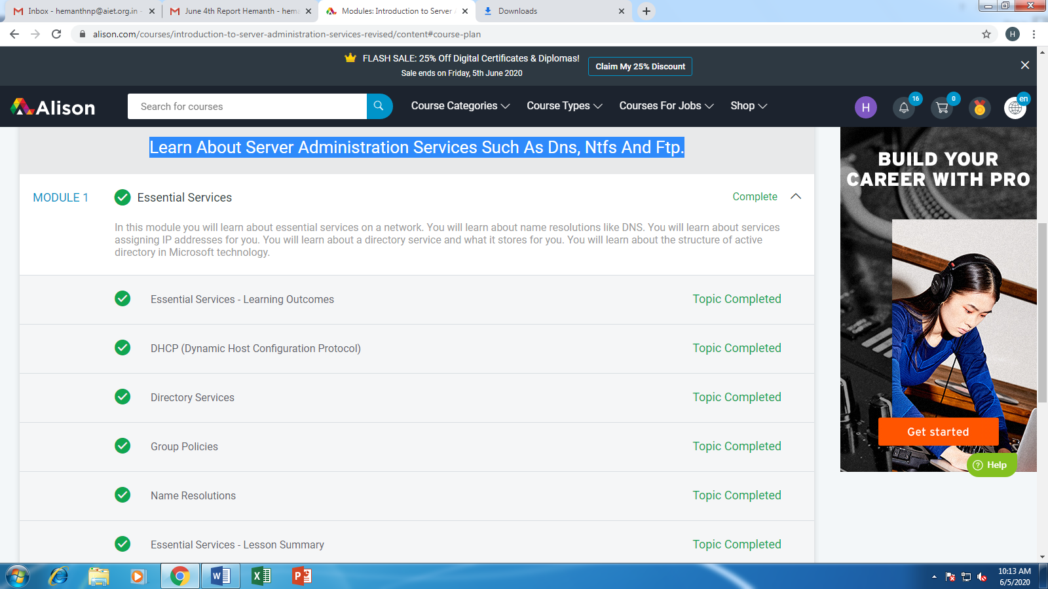

**List of 2nd year Students assigned along with their github repository names**

|  |  |  |  |
| --- | --- | --- | --- |
| **S. No** | **USN** | **Name** | **GitHub Repository URL’s** |
|  | 4AL16CS049 | Manibhushan Nadendla | <https://github.com/nadendlamanibhushan?tab=repositories> |
|  | 4AL18CS001 | Abhishek Joshi | Not accepted the invitation |
| 3. | 4AL18CS002 | Abhishek S Harsoorkar | <https://github.com/abhisheksharsoor?tab=repositories> |
| 4. | 4AL18CS003 | Adarsha N Y | Not accepted the invitation |
| 5. | 4AL18CS004 | Akash S | <https://github.com/akashacharya786?tab=repositories> |
| 6. | 4AL18CS005 | Ambika V | <https://github.com/ambika0202?tab=repositories> |
| 7. | 4AL18CS006 | Amrutha G | <https://github.com/AMRUTHAGANESH?tab=repositories> |
| 8. | 4AL18CS007 | Anjali Manohar Prabhu | <https://github.com/vinisharen?tab=repositories> |
| 9. | 4AL18CS008 | Anush Ratnakar Shetty | <https://github.com/anushshetty30?tab=repositories> |
| 10. | 4AL18CS009 | Anusha K | <https://github.com/anusha20219?tab=repositories> |
| 11. | 4AL18CS010 | Anvitha H M | <https://github.com/anvithahm?tab=repositories> |
| 12. | 4AL18CS011 | Archana J C | <https://github.com/Archanajchinnaswamy?tab=repositories> |
| 13. | 4AL18CS012 | Ashish Gracion Menezes | <https://github.com/ash7745?tab=repositories> |
| 14. | 4AL18CS013 | B A Sohankumar | <https://github.com/sohannaik5648987?tab=repositories> |
| 15. | 4AL18CS014 | Bhavya S | <https://github.com/Bhavyamahadev?tab=repositories> |
| 16. | 4AL18CS016 | Chandana S | <https://github.com/chandushivalingareddy?tab=repositories> |
| 17. | 4AL18CS017 | C K Chethan | <https://github.com/chethan-ck?tab=repositories> |
| 18. | 4AL18CS019 | Churashma | <https://github.com/Churashma?tab=repositories> |
| 19. | 4AL18CS020 | D Richard Franklin | <https://github.com/richard3658?tab=repositories> |

